Name: ___________________

**Micrometer Worksheet #2**

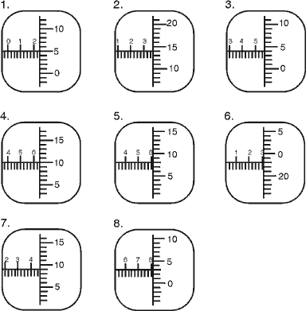

|  |  |
| --- | --- |
| 1 |  |
| 2 |  |
| 3 |  |
| 4 |  |
| 5 |  |
| 6 |  |
| 7 |  |
| 8 |  |

