Name: __________________________ Date: ________________________

**Science 7: Scientific Method**

Today’s Objectives:

* **I can** differentiate between inferences and observations.
* **I can** explain the six components of the scientific method

Which of the following statements is subjective? Put a **“S”** next to the **subjective** statements, or “**O”** by the **objective** statements.

* 1. Scholars who come to class and work hard will succeed. ______
  2. 52 people said they liked the book. 48 said they did not. ______
  3. This is the most beautiful dress in the world. ______
  4. The table is 34 inches long. ______

1. Label the following scientist statements as either **objective** or **subjective** (which means “not objective”).

That soup looked weird, so I tasted that soup and found out that it tasted bitter.

________________________________________________________________

That soup looks weird. It must be disgusting.

________________________________________________________________

1. Using the two sentences above, in **2-4 sentences,** explain what made one statement objective and the other subjective.

_________________________________________________________________________________________________________________________

_________________________________________________________________________________________________________________________

_________________________________________________________________________________________________________________________

_________________________________________________________________________________________________________________________

_________________________________________________________________________________________________________________________

1. Are the observations in #2 **quantitative** or **qualitative** statements?

________________________________________________________________

**Guided Notes:**

**What is *Scientific Inquiry*? _________________________________________________________________________________________**

**_________________________________________________________________________________________________________________________**

**What is an *inference*? ______________________________________________________________________________________________**

**_________________________________________________________________________________________________________________________**

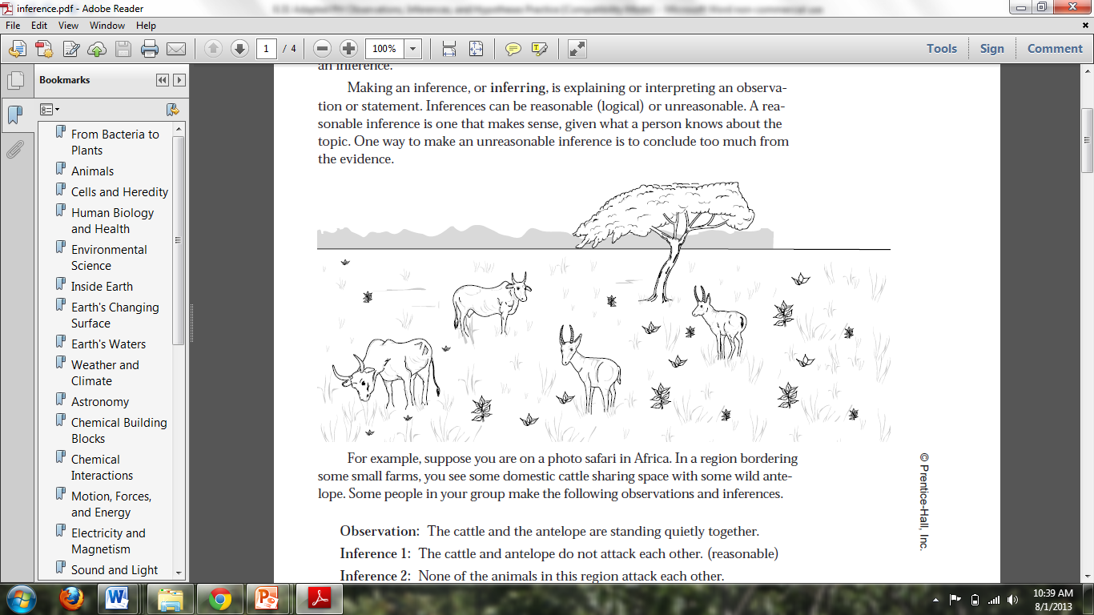**Observation 1:** The cattle and the antelope are standing quietly together.

**Inference 1: ____________________________________________**

**___________________________________________________________**

**___________________________________________________________**

**Observation 2:** Some of the cattle are eating grass.

**Inference 2: _________________________________________________________________________________________________________**

**_________________________________________________________________________________________________________________________**

**What are the 6 steps of the Scientific Method?**

1. ___________________________________________________________
2. ___________________________________________________________after making an observation.
   * This is written in the form of a question.

Example: Which of these two paper towel brands will absorb more water?

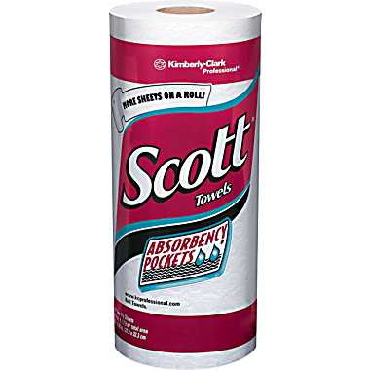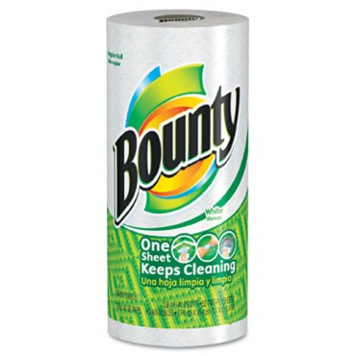

1. ___________________________________________________________
   * A hypothesis is a possible answer to your question. It is usually

based on the *inference* made from the observation!

* + It is a testable statement (more on this later…)

Example: If Bounty is thicker than Scott, then Bounty will absorb more water.

1. ___________________________________________________________

Example: How would you test which paper towel will absorb more?

* + - Spread out a certain amount of liquid
    - Use the paper towel to pick up as much as you can
    - Measure how much is left over

1. ___________________________________________________________**_**
   * Includes creating tables or graphs to look for trends.
2. ___________________________________________________________
   * Here you look at the data from the experiment to see if your hypothesis was correct or incorrect.

**Let’s Practice! Inferences (I Do)**

**Part 1:** Let’s make some observations and inferences about the following picture:



**Observation 1: ______________________________________________________________**

**_________________________________________________________________________________**

**Inference 1: _________________________________________________________________**

**________________________________________________________________________________**

**Part 2:** Decide if the following statements are observations or inferences by circling the word.

1. The sun is yellowish today.

**OBSERVATION INFERENCE**

1. This must be a school because there are teachers, children, desks, and books.

**OBSERVATION INFERENCE**

**Scientific Method:** Scrambled Scientific Method

These scientists’ inquiries have gotten all mixed up! Can we put them in the correct order? Label each sentence of the scientist’s inquiry with its corresponding step in the scientific method.

Example 1:

|  |  |
| --- | --- |
| Scientist Actions | Step in the Scientific Method |
| 1. The scientist predicts that changing the batteries will fix the problem. |  |
| 1. The scientist wonders why his flashlight not is not turning on. |  |
| 1. The scientist notices that his flashlight will not turn on. |  |
| 1. The scientist determines that it must have needed new batteries. |  |
| 1. The scientist takes out the old batteries, puts new ones in and tries to turn it on. |  |
| 1. The scientist notes that the flashlight is now working again. |  |

List the numbers of the statements in the correct order._________________________________________________________

**Inferences (We Do)**

**Part 1:** Let’s make some more observations and inferences about the picture above:

**Observation 2: ___________________________________________________________________**

**______________________________________________________________________________________**

**Inference 2: _______________________________________________________________________**

**______________________________________________________________________________________**

**Observation 3: ______________________________________________________________________________________________________**

**Inference 3: _________________________________________________________________________________________________________**

**Part 2:** Decide if the following statements are observations or inferences by circling the word.

1. There are 8 students in this classroom.

**OBSERVATION INFERENCE**

1. The sun is shining.

**OBSERVATION INFERENCE**

1. It must be winter because it is snowing.

**OBSERVATION INFERENCE**

6. It took the students 2.35 seconds to stand up today.  
 **OBSERVATION INFERENCE**

**Scientific Method:** Scrambled Scientific Method

These scientists’ inquiries have gotten all mixed up! Can we put them in the correct order? Label each sentence of the scientist’s inquiry with its corresponding step in the scientific method.

Example 2:

|  |  |
| --- | --- |
| Scientist Actions | Step in the Scientific Method |
| 1. The scientist cuts the stained shirt in half and washes each side with a different cleaner. |  |
| 1. The scientist wonders if one cleaner will get the stain out better than the other. |  |
| 1. The scientist needs to get a stain out of his uniform. He finds two different cleaners (ALL and PUREX) in the laundry room. He notices that both claim to get stains out the best. |  |
| 1. The scientist rejects his hypothesis. |  |
| 1. 5. t the numbers of t_______________________they did not. that they did would have recieved increase because ________________The scientist then measures the size of the remaining stain and notes that the stain remaining on the side washed with ALL detergent is 3 cm smaller than the one washed with PUREX detergent. |  |
| 1. The scientist proposes that both of the cleaners will clean the stain equally well. |  |

List the number of the statements so that they are in the correct order.

__________________________________________________________________________________

**Your Turn to Practice on Your Own!**

**Inferences**

**Part 1:** Let’s make some observations and inferences about the following picture:

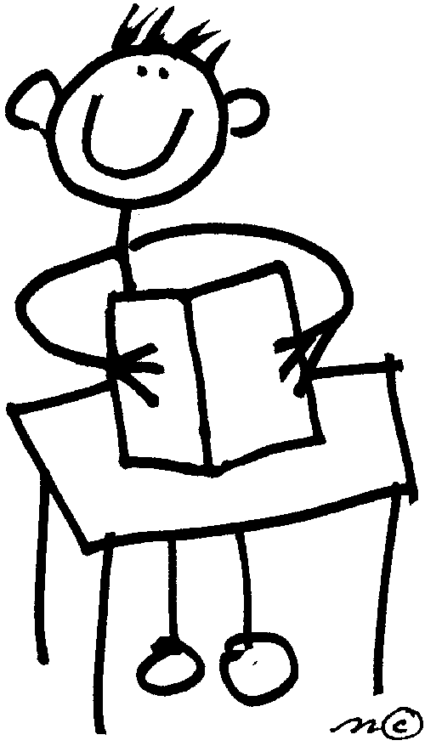

**Observation 1: _________________________________________________________________________**

**____________________________________________________________________________________________**

**Inference 1: ____________________________________________________________________________**

**____________________________________________________________________________________________**

**Observation 2: _________________________________________________________________________**

**____________________________________________________________________________________________**

**Inference 2: ____________________________________________________________________________ ____________________________________________________________________________________________**

**Part 2:** Decide if the following statements are observations or inferences.

1. Eric did not do as well on this test as he usually does. He probably didn’t study for the test.

**OBSERVATION INFERENCE**

1. Katie is absent today.

**OBSERVATION INFERENCE**

1. There were 32 people on the bus this morning.

**OBSERVATION INFERENCE**

1. My flowers grew better at the end of the garden, so this part must get more sunlight.

**OBSERVATION INFERENCE**

**Scientific Method:** Scrambled Scientific Method

These scientists’ inquiries have gotten all mixed up! Can we put them in the correct order? Label each sentence of the scientist’s inquiry with its corresponding step in the scientific method.

|  |  |
| --- | --- |
| Scientist Actions | Step in the Scientific Method |
| 1. The scientist needs to buy an ice pack for his lunch. He notices that there are ice packs that are made with two different kinds of materials at the store. |  |
| 1. The scientist designs an experiment to determine which ice pack keeps his lunchbox cooler after sitting out for a morning. |  |
| 1. The scientist measures the temperature in each of the lunch boxes just before eating lunch and records the temperatures. They are the same. |  |
| 1. 4. _____________________________The scientist predicts that one ice pack will keep his lunch box colder than the other. |  |
| 1. The scientist rejects his hypothesis. |  |
| 1. The scientist asks himself if the material in one of the ice packs will keep his lunch cooler than the other. |  |

Re-write the numbers of the statements so that they are in the correct order.

__________________________________________________________________________________

**College & Career-Ready Challenge**

Go back to Part 2 of the “I Do” section you just completed. Justify the answers you chose in complete sentences. Explain how you determined whether the statement was an observation or an inference.

1. _________________________________________________________________________________________________________________

_________________________________________________________________________________________________________________

1. _________________________________________________________________________________________________________________

_________________________________________________________________________________________________________________

1. _________________________________________________________________________________________________________________

_________________________________________________________________________________________________________________

1. _________________________________________________________________________________________________________________

_________________________________________________________________________________________________________________

Name: __________________________ Date: ________________________

Science 7

**Exit Ticket**

1. Draw a line to match each step in the scientific method with its corresponding step in the scientist’s inquiry.

|  |  |  |
| --- | --- | --- |
| 1. 1. ence Advisory:_______________ Date:_________________The scientist proposes that the amount of sunlight a plant is exposed to could affect the height of the plant. |  | observe and research a phenomenon |
| 1. A scientist wonders if the amount of sunlight the plants are exposed to affects how tall they grow. |  | draw and communicate a conclusion |
| 1. Every day the scientist measures the grass and compares the measurements of those in the shade vs. those in the sun. He notices that the measurements of the plants in the sun tend to be taller than those in the shade. |  | propose a hypothesis |
| 1. A scientist notices that grass in one area of his yard is taller than grass in another area of his yard. He goes to the library and learns researches factors that impact plant growth and learns that sunlight can impact plant growth. |  | formulate a question |
| 1. The scientist designs an experiment placing one set of plants in the sunlight and one in the shade. |  | Conduct the experiment |
| 1. The scientist concludes that his results support his hypothesis: that sunlight can affect how tall plants grow. |  | collect and interpret data |

1. Which of the following **is an inference?**
   1. There’s an empty aquarium tank in the classroom.
   2. The tank is 50 cm long, 30 cm wide, and 18 cm deep.
   3. The tank used to contain live fish.
   4. The tank is a rectangular shape.